Corporate Art Workshops
Deanne Newland
Artistic Soul Studio
http://www.deannenewland.com/
Challenge your team, take them out of their comfort zone and stretch their imagination to collaborate with colleagues, create art and find new paths of communication. Corporate art workshops are a fantastic team building exercise where participants compete on a level playing field where anyone can excel.
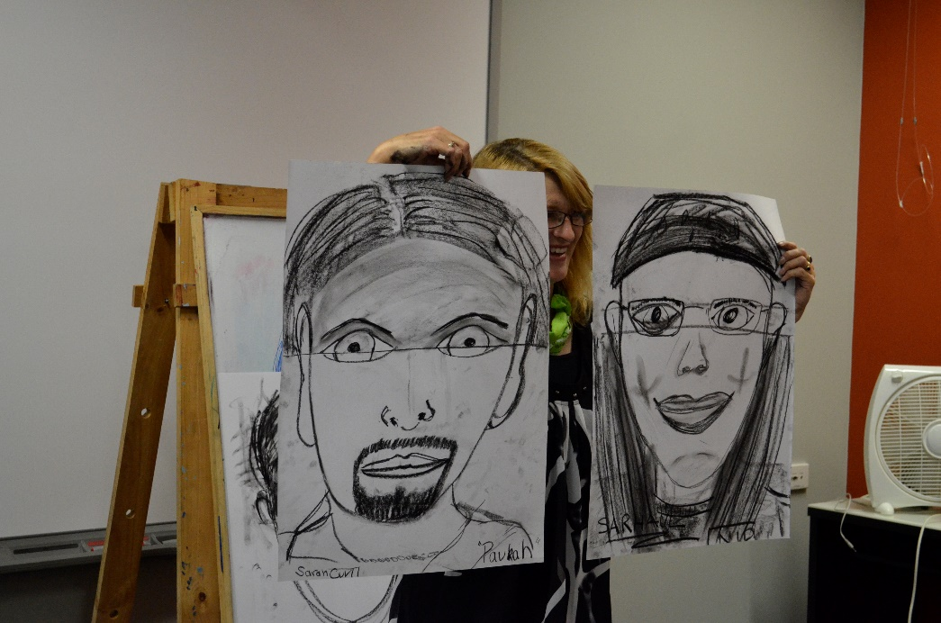
​The primary focus of these workshops are to build relationships and enhance communication and collaboration capabilities amongst team members in a fun and relaxed forum. Staff are randomly placed in small teams to collaborate and produce works of art. Typically there are three challenges in a half day workshop where teams are chopped and changed to enrich the experience and challenge dynamics of the whole team.
​
Deanne Newland is a contemporary artist, educator and owner of The Artistic Studio Art School catering to students of all ages and artistic capabilities. Deanne has acquired a Batchelor of Visual Arts and Diploma in Education which in addition to practising art her entire life is well equipped to guide your team in a workshop environment.
Guidance and encouragement of teams to complete their tasks will be provided by Deanne. The process of completing unfamiliar tasks is in itself an achievement that all participants should celebrate. The resulting artworks are often surprising in the innovation that teams deliver. There is no right or wrong in theses workshops, simply stepping out of normal corporate constraints and communicating on a personal level creates invaluable team camaraderie.

Artistic Soul Studio
“Study the science of art and the art of science. “
Leonardo da Vinci
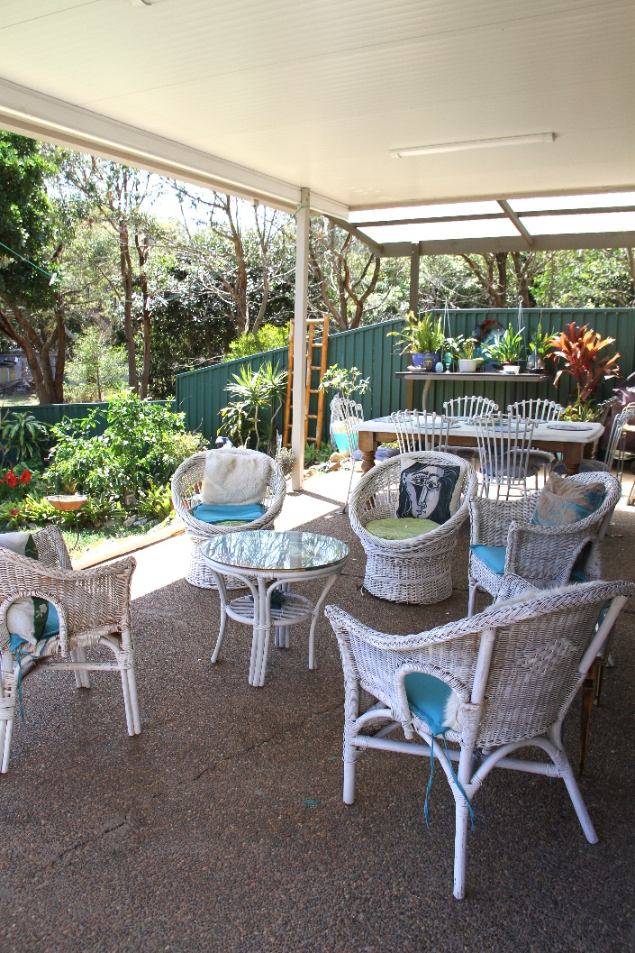

Deanne’s Art Studio/workshop at Swansea Heads can be utilised for minimum fuss and accommodate up to 10 team members.
The Studio is adjacent to a nature reserve and walking track to Frenchman's beach, a tranquil space away from the office.
The studio has indoor and outdoor areas which can be utilized on a warm day. There is space for everyone to sit down for some refreshments if you would like to break and relax during the workshop. The studio has tea and coffee facilities and a fridge to keep drinks cold.

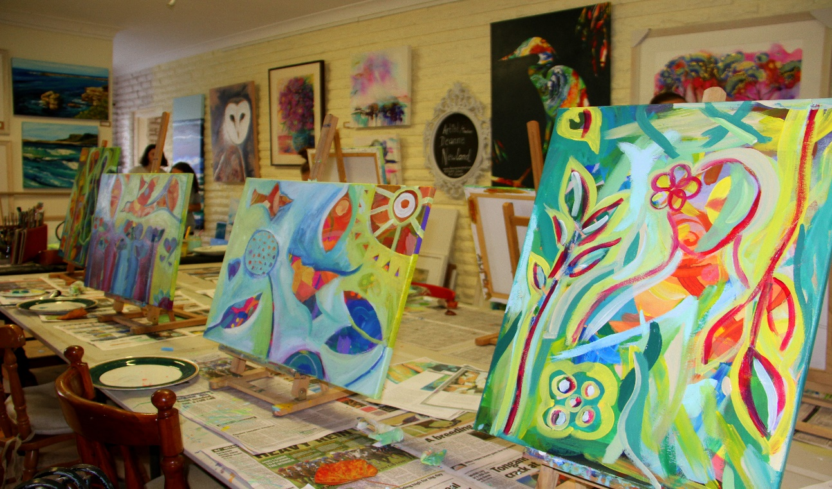

On-site Workshops
Rooms: Workshop rooms need tables clear of all items/clutter with adequate room for movement around the tables. It is preferred to have individual tables spaced around the room for teams to work at. Long or joined tables will work, just ensure there is adequate space for each team member.
Art can get messy! Deanne will provide protective covers for desks to keep the clean up to a minimum. If the class you choose uses paints or inks it is advised not to work in carpeted areas. Deanne will have basic clean-up materials on hand and assist if a spill occurs but cannot take responsibility for your environment. Deanne will provide containers/pallets suited for the workshop to minimise mishaps.
Parking space: To facilitate an art workshops there is often a fair amount of materials required to be brought on premises. Deanne will need a dedicated parking spot close to where the workshop is held. A trolley or a few hands on deck to assist Deanne with unloading/reloading materials will be helpful. Workshop setup and pack up time will be included in the cost so keep this in mind.
Your workshop
You can choose from a variety of art making activities including drawing, painting, mixed media, clay, creative collage, and more. The cost of any workshop will vary with the chosen medium, participant numbers, workshop length, venue and materials required. Deanne will work with you to accommodate your budget.
All materials can be provided for the workshop at a reasonable cost. Deanne stocks quality paper, canvases, paints and equipment. To minimise cost you are welcome to provide your own consumables such as pencils, paper, canvases, paints and brushes or a combination of your own and Deanne’s stock. Non consumables such containers and pallets are included in the workshop cost. Deanne will happily assist with information regarding what and where to source materials at a budget price.

Cost: To assist quotation of your workshop please contact Deanne via e-mail at artisticsoul.newland81@gmail.com with as much information as known from the list below.
- Contact Name(s)
- Contact Phone Number(s)
- Contact Email(s)
- Company Name
- Workshop On-site/Studio
- Workshop Length of Time
- Event Date(s)/times (if known)
- Number of Participants
- Budget (per participant or group)
- Corporate Objectives for Event
- Team background (Lawyer’s, Architects, Administrative, IT, Marketing, HR etc…)

